**Web-Based Application for MAAB Registration**

**for Philippine Red Cross Baguio City Chapter**

**By:**

**Cayabyab, Emarie A.**

**Pascua, Ara Coleen J.**

**Toledo, Jann Michael U.**

**Saint Louis University On-the-Job Trainees**

**Bachelor of Science in Information Technology**

JULY 2018

**Red Cross MAAB System Overview**

This Section provides a description of the Red Cross MAAB system including its definition, primary goal, context, capabilities and utilization.

**Definition**

The Red Cross MAAB System will be a intranet Web based system bringing together personnel of Philippine Red Cross Baguio City Chapter to have the privilege to register new memberships and handle renewal of membership, with the use of either mobile phones, tablets, laptops or computers which are connected on the same network.

**Objectives**

To help Philippine Red Cross Baguio City Chapter in:

* Automating their manual membership system.
* Lessening the use of paper and save it for other paper works.
* Properly monitoring membership most especially those Expiring Membership.
* Having a backup of every data.
* Having a protection against data loss, and in order to avoid the risk of losing paper works or folders caused by misplacement, fire hazard and water hazard.
* Make the registration easily and reliable.

**External Hardware**

The Red Cross MAAB system interacts, either directly or indirectly, with the following significant external hardware:

* **Client Hardware:**
  + **Employee Workstations -** personal computers used by the employees to perform their tasks.
  + **User Client** - personal smartphones used by users to communicate with each other and with the Red Cross MAAB system over the intranet.
* **Networks:**
  + **Local Area Network** - the Red Cross MAAB internal *local area network* (A network that associates devices and share a common communication line) used for computer communication among employees, clients and the Red Cross MAAB system.

**External Roles**

The Red Cross MAAB system interacts, either directly or indirectly with the following significant roles:

* **Employees,** any actors who works for Philippine Red Cross Baguio City Chapter
  + **Accountant**, Philippine Red Cross employees who perform accounting functions.
  + **System Administrator,** any authorized user that ensures the data in the system are correct.
* **Users,** any individual that avails/inquire Red Cross Memberships in the RCM.
  + **Clients**, who are any users who use the RCM system to register, renew and to know the validity of their memberships.

**External Software**

These are the necessary software of a computer device to use the Red Cross MAAB system.

* **Browser** - a software tool that runs on employee and user personal computers/devices that allow them to communicate over the network with the Red Cross MAAB (RCM) system.

**MINIMUM SYSTEM REQUIREMENTS**

These are the necessary specifications of the server computer to have, in order to use the run the Red Cross MAAB system.

* Windows 7 (32/64 bit) Intel Processor or AMD Processor
* Built in discrete Graphics Card
* 1 GB RAM
* 500MB available hard drive space
* Broadband Internet/ Intranet Connection

**Rationale for Project Development**

At the day of the orientation, one of the task that was demonstrated to the on-the-job trainees is facilitating the red cross membership. Upon observing, the client will write the necessary information to the membership form. After gathering the necessary details, the process will proceed to SI and payment. At the end of the day all of the data in membership forms will be encoded to a single excel file. The current MAAB registration relies on the use of paper in recording data about the clients availing the membership. There is a backup for every data recorded, but only with the use of a spreadsheet application.

During our duty at the Multi Service Office, we encountered and observed some problems at the MAAB registration. These are the problems that we assessed:

1.) Not all information and new membership are recorded.

2.) Some of the details of are incomplete.

3.) Some of the unrecorded membership forms are missing.

4.) The company doesn't have complete past records that may be used for future references.

5.) The company monitor expiring membership by obtaining the data one by one from

spreadsheet application, making a list of contact details and to easily notify the person.

During the orientation it was also suggested to the on-the-job trainees to automate the MAAB registration process. With all of these observations, we decided to create a system that may help the development of Red Cross Membership process. We aim to help the Red Cross Baguio City Chapter to ensure the integrity of the information, monitor the recording of membership and also to lessen the workload and stress to missing papers.

The system was

Refer to the figure below.

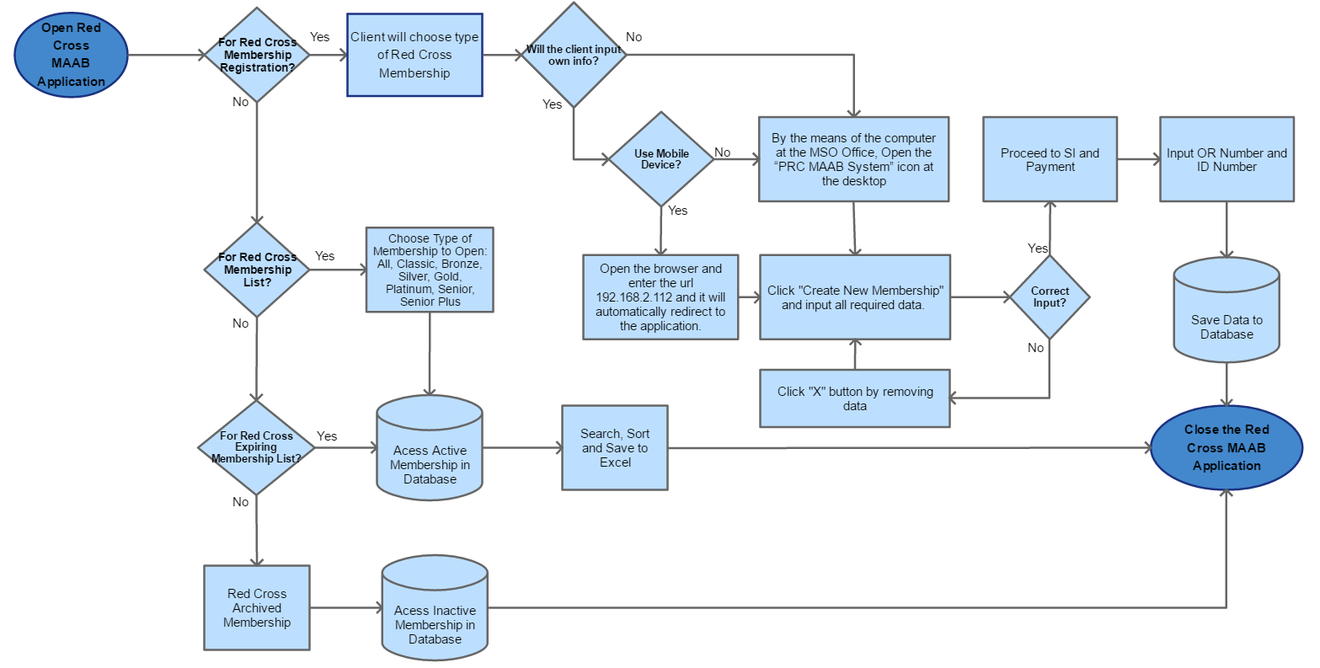

**Features**

In order to help Red Cross Membership, we designed the system into simple way to use it. The system capabilities are the following:

* Easily create membership and save the information to the database.
* The application can be used through mobile phone browser.
* Deletion of data upon registration is available.
* With the same network, Computers/mobile phones can access the homepage of the system. Clients can only view the registration while the system’s database can only be viewed on the server computer.
* Membership accommodated to the current date can be easily seen at the “Registration” page of the system.
* Active membership can be seen at the “Membership List” page and it is automatically sorted out based on the membership type or level.
* A table of the list of Expiring members for the next month is also available to the “Expiring Members” tab.
* “Save to excel” button is provided, in order to easily save a copy of a specific table to the computer of the staff.
* An “Archive” tab is provided, in order for the company to easily identify expired membership.

**UTILIZATION OF THE RED CROSS MAAB SYSTEM (STEP BY STEP)**

The web application can be accessed on the staff computers on the Multi-Purpose Office. The application is located at the desktop, namely Red Cross MAAB. However, the system can also be accessed through mobile phones by opening web browser and by visiting the IP Address 192.168.2.112.

***IMPORTANT NOTE:*** *In order to connect to the system, the user should be connected to the same network as the server.*

**For Personal Computers**

Simply open the ***“PRC MAAB System”*** icon at the desktop and it will automatically redirect the user to the application.



**For Mobile**

Simply open the browser and enter the url ***192.168.2.112*** and it will automatically redirect the user to the application.

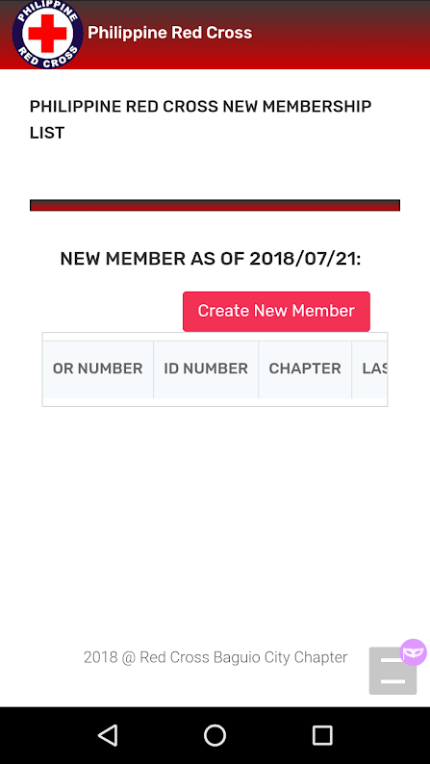

**Client Mobile/Phone Registration:**

The Red Cross MAAB mobile/phone homepage allows the client to register to the system by pressing the Create New Member.

The homepage also shows the recent registration which the client can also review the details that they have recently entered.

***IMPORTANT NOTE****: Be careful on using the* ***remove button*** *for the records removed in the application is also removed in the system’s database.*

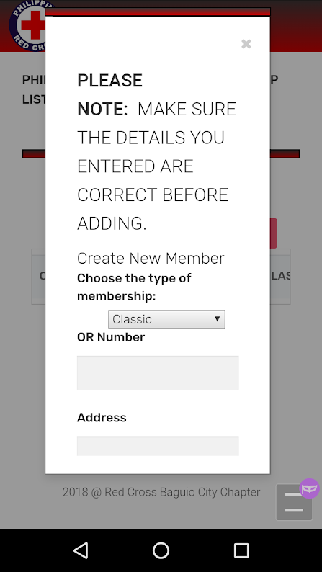

**Client/Mobile Create New Membership:**

Upon pressing the Create New Membership button, A modal will appear and requires the user to input their necessary information for the membership such as Type of Membership, OR Number, ID Number, Member Name (First Name, Middle Name, Last Name), Address, Contact Number, Birthdate, Age, Gender, Date of Validity and Expiration.

If the client had incurred mistakes in the form they can simply erase the fields or they can press on the x button at the top of the form to redo the process again.

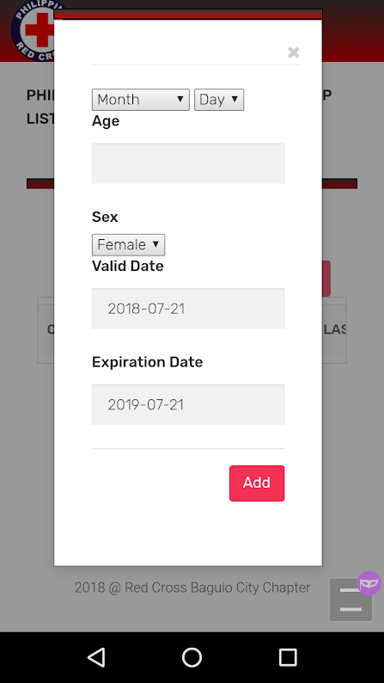

**Finishing Up the Mobile Registration**

Once the necessary client details are provided and counter-checked by the client.

Pressing the add button at the end of the form adds the information on the system’s database will be both be displayed at the client’s mobile/phone home page as well as the computers connected to the Red Cross MAAB system as well.

**HOW TO USE RED CROSS MAAB SYSTEM:**

**REGISTRATION**

The “Registration” tab contains a list of all new membership of the current date. The company can validate all of the membership that was entered that day. See figure below.

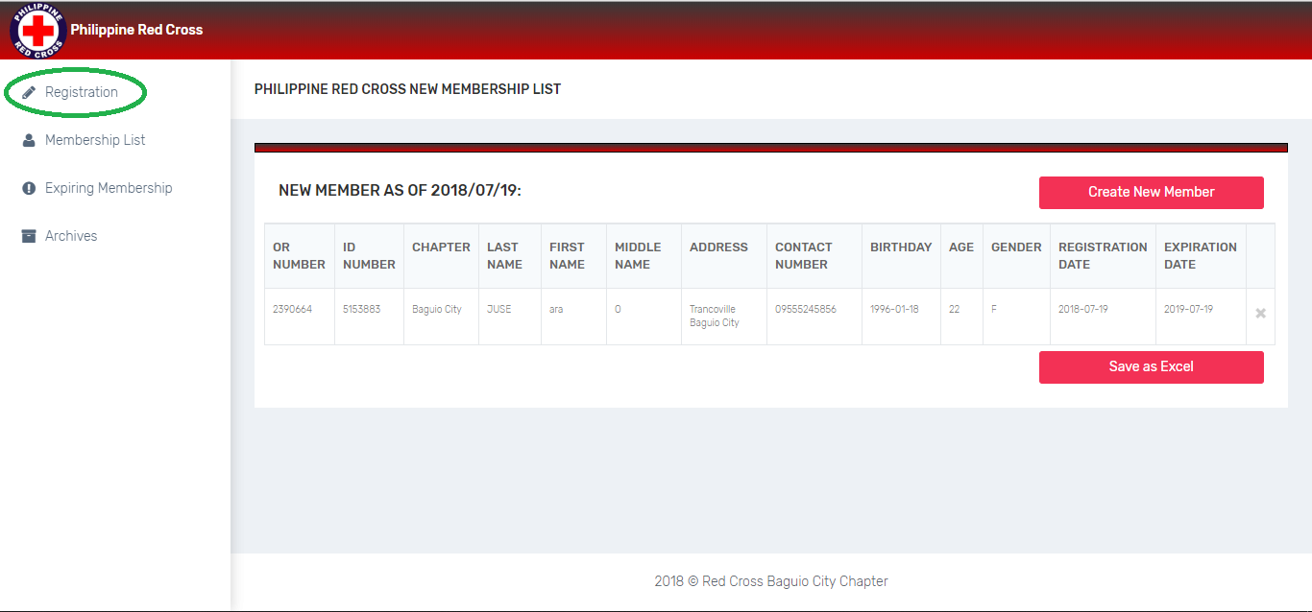

***IMPORTANT NOTE:*** *NOT FILLING UP the following will not be accepted by the system:* ***OR NUMBER, ID NUMBER, NAME AND BIRTHDATE****. This can also be done by the clients with the use of their personal mobile phones. The Staff assigned should always double check the legitimacy of the details provided by the client.*

***Steps to add a New Membership:***

1. Simply click the *“Create New Member”* Button.

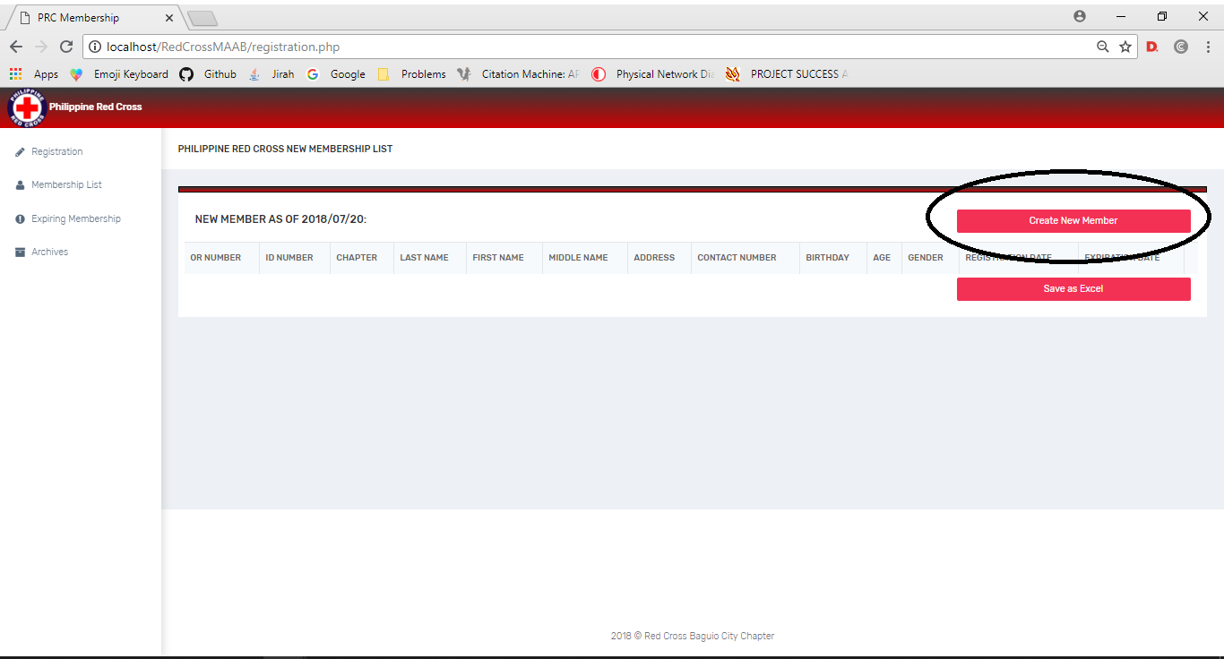

2.) A modal will appear and requires the user to input their necessary information for the membership such as Type of Membership, OR Number, ID Number, Member Name (First Name, Middle Name, Last Name), Address, Contact Number, Birthdate, Age, Gender, Date of Validity and Expiration.

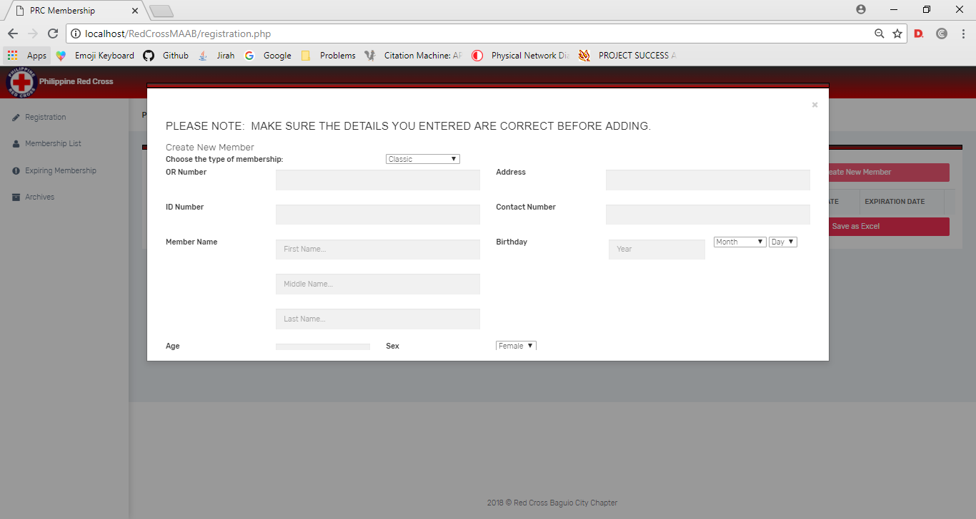

3.) Just click the *“Add”* button to successfully add the information to the database

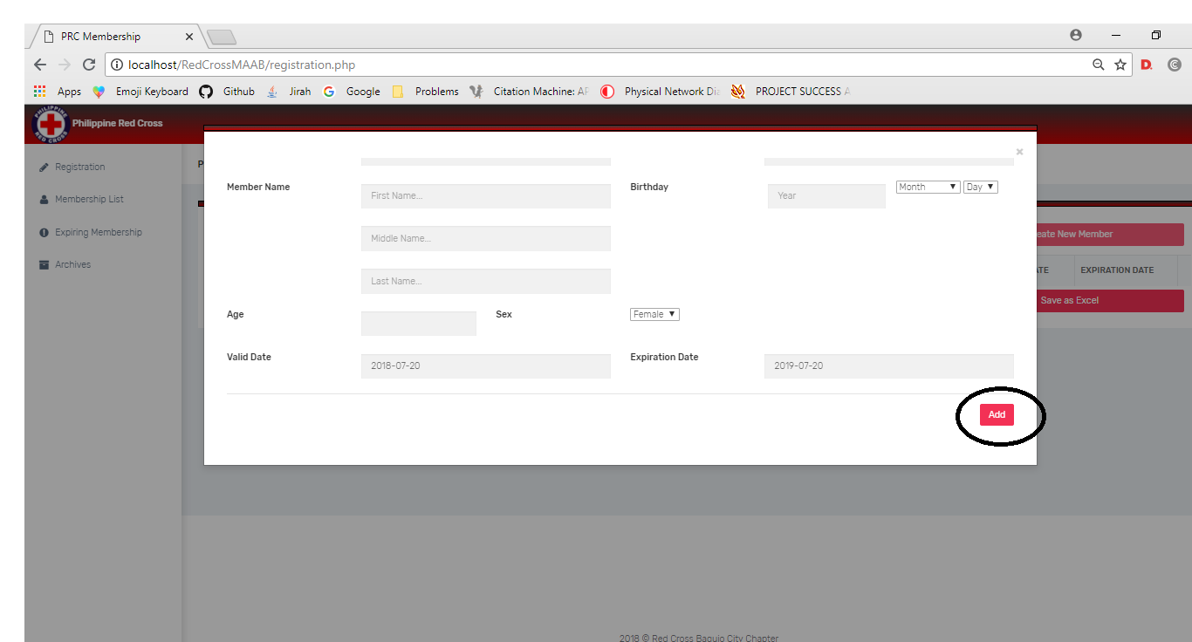

4.) After adding, you can validate the information entered by looking at the table at the “Registration” tab. In case that entered data is incorrect, click the “x” button at the right side of incorrect data to remove and re-enter the information by repeating the first step.

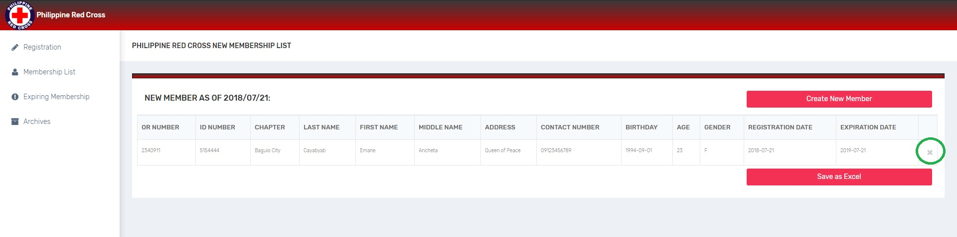

***IMPORTANT NOTE:*** *Please make sure that the staffs are the only one who are allowed to click the* ***remove button*** *and make sure that the user staff is clicking the right remove button. In this case, Clicking the button accidentally can cause deletion of data to the database without prompt.*

**MEMBERSHIP LIST**

This page consists of all active and valid membership. Memberships are sorted out and categorized based on the type of membership such as Classic, Premier Bronze, Premier Silver, Premier Gold, Premier Platinum, Senior and Senior Plus.

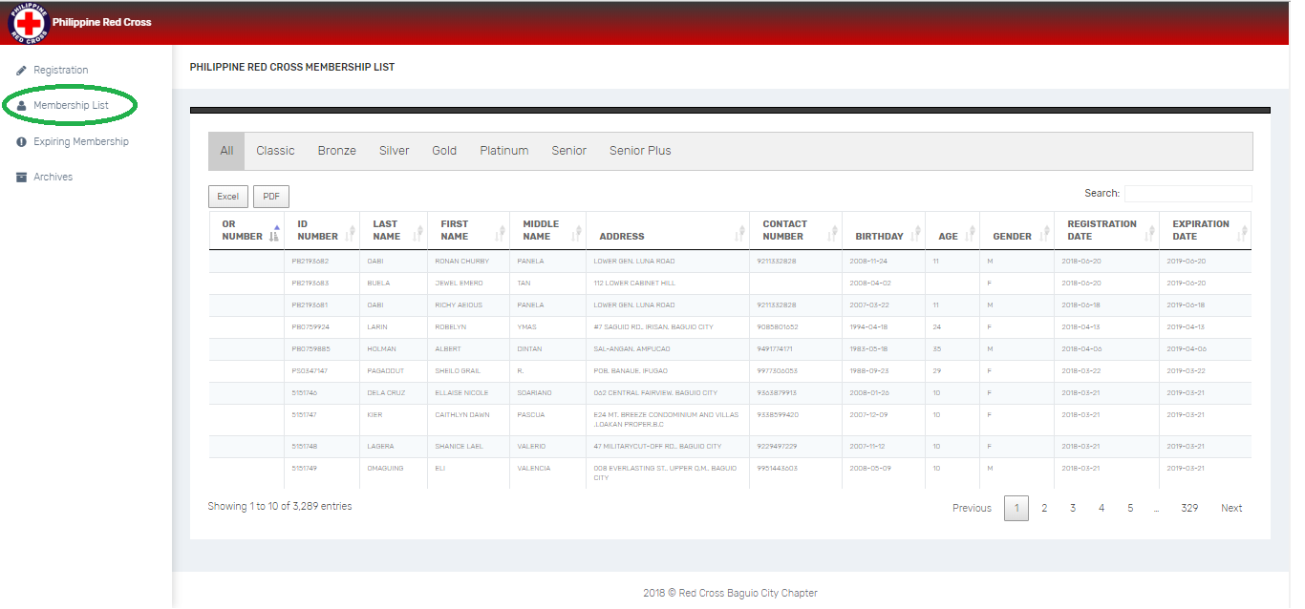

**Displaying Valid membership registrations (According to category)**

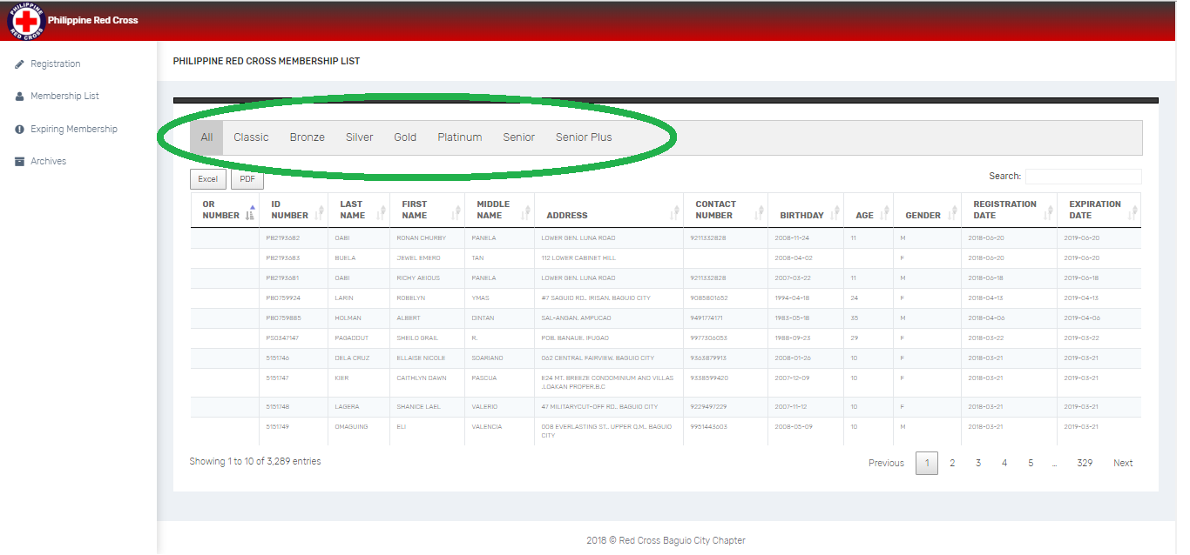In this page you can see the list of members accordingly. Simply Click to the tab of desired category and it will display list of members of the specific type.

**EXPIRING MEMBERSHIP**

This page displays a table that consist of all expiring memberships 1 month prior on membership validity expiration. This will serve as a notification in order to contact and remind the member about the expiration of the membership. The table displays all important information only such as OR Number, ID Number, Name, Contact number and Address for references.

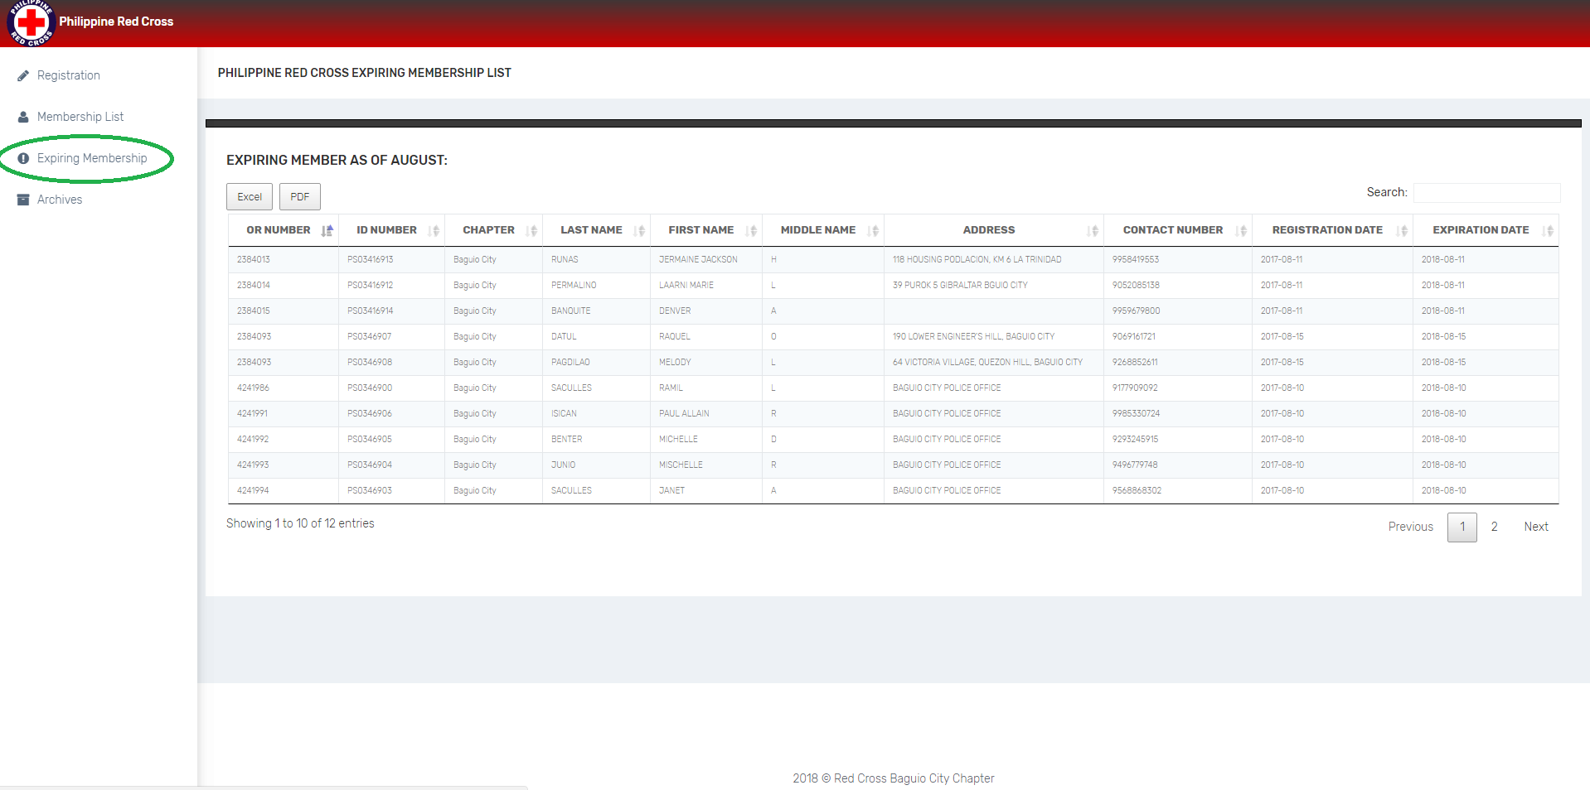

**ARCHIVE**

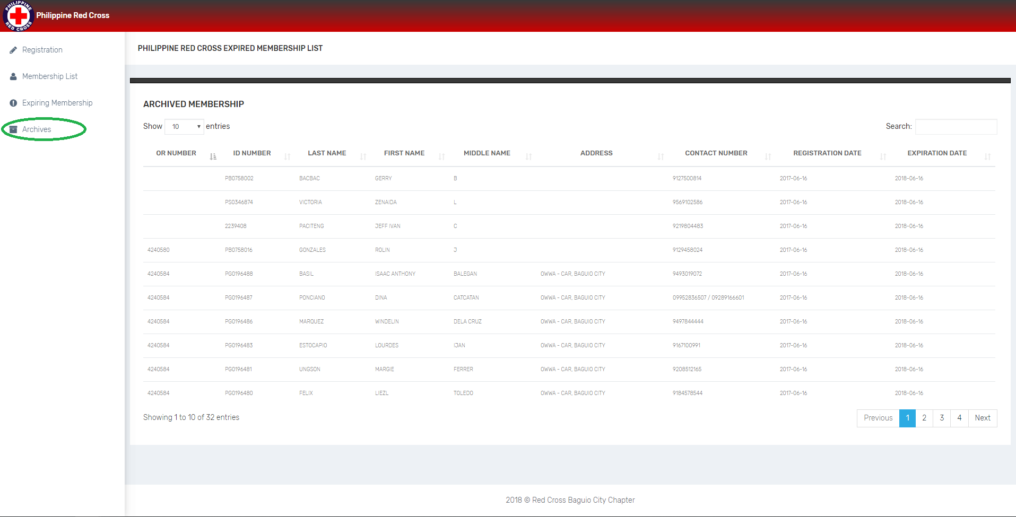In this page you will see all *Expired Membership*. This record will serve as a reference for future purposes.

**SEARCH**

A search field is provided located at the upper right of membership list table, expiring members table and archives table. This is will be used for searching specific name or specific registration date and etc. It is provided for the company for easy way to look for a certain membership.

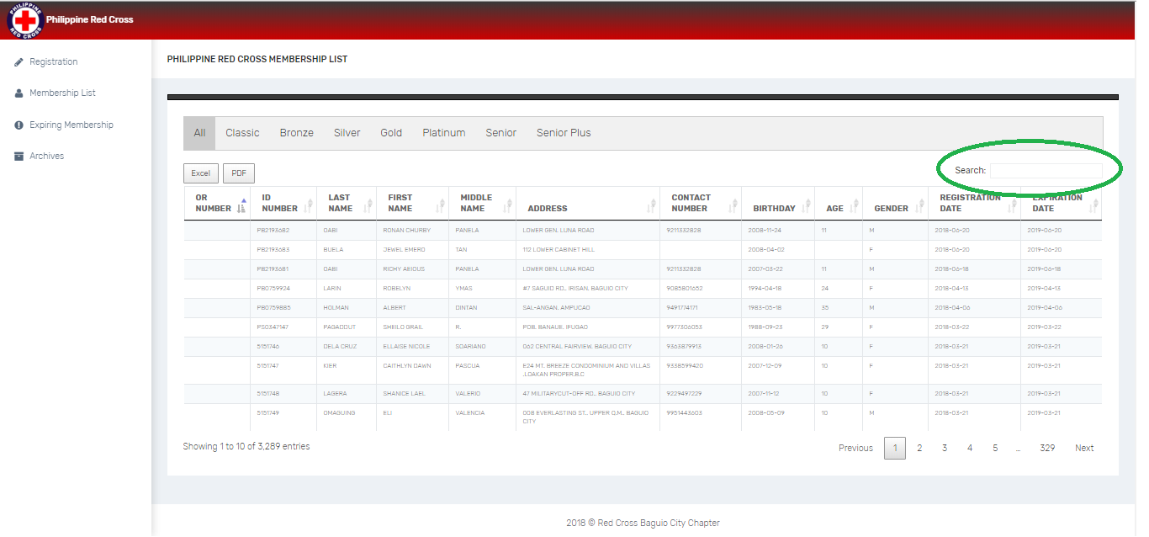

**SORT**

In order to sort tables according to column name at the membership list, expiring members and archives table, simply click the header of the specific column.

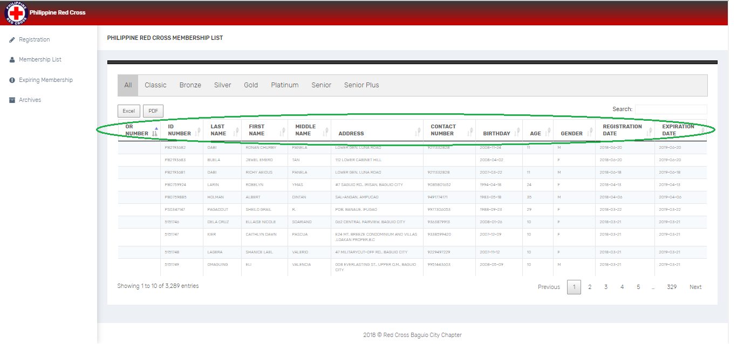

**TOTAL NUMBER OF ENTRIES**

The count of membership can be seen at the lower left of the table. Specifically membership list and expiring membership tables. instead of counting a lot of numbers, the table provides a number of membership that serves as a basis for the total number of entries.

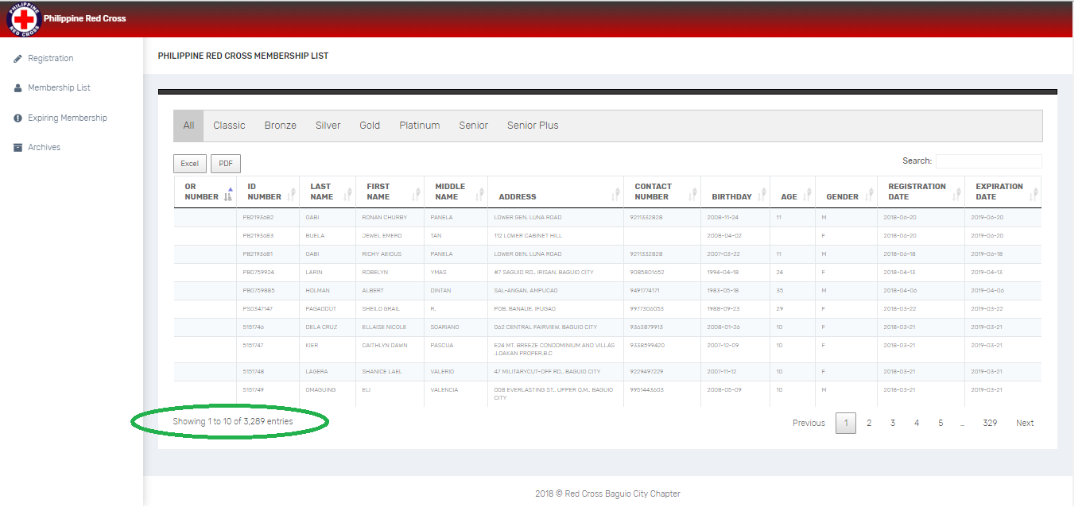

**SAVE AS EXCEL**

Save the table as an excel file is specifically for registration, expiring members and member list table only. In order to help the company, the developers integrated save to excel feature for them to have a physical copy and having an option of printing it. With the company legacy system, they are sending the records with excel format to the main office. The developers designed the system in such a way because the system will be implemented explicitly to the Philippine Red Cross Baguio City Chapter.

**Expiring Membership**

If the user wants to save or have a copy of all Expiring Membership for next month:

* Click “Excel” button and it will automatically download an excel file.

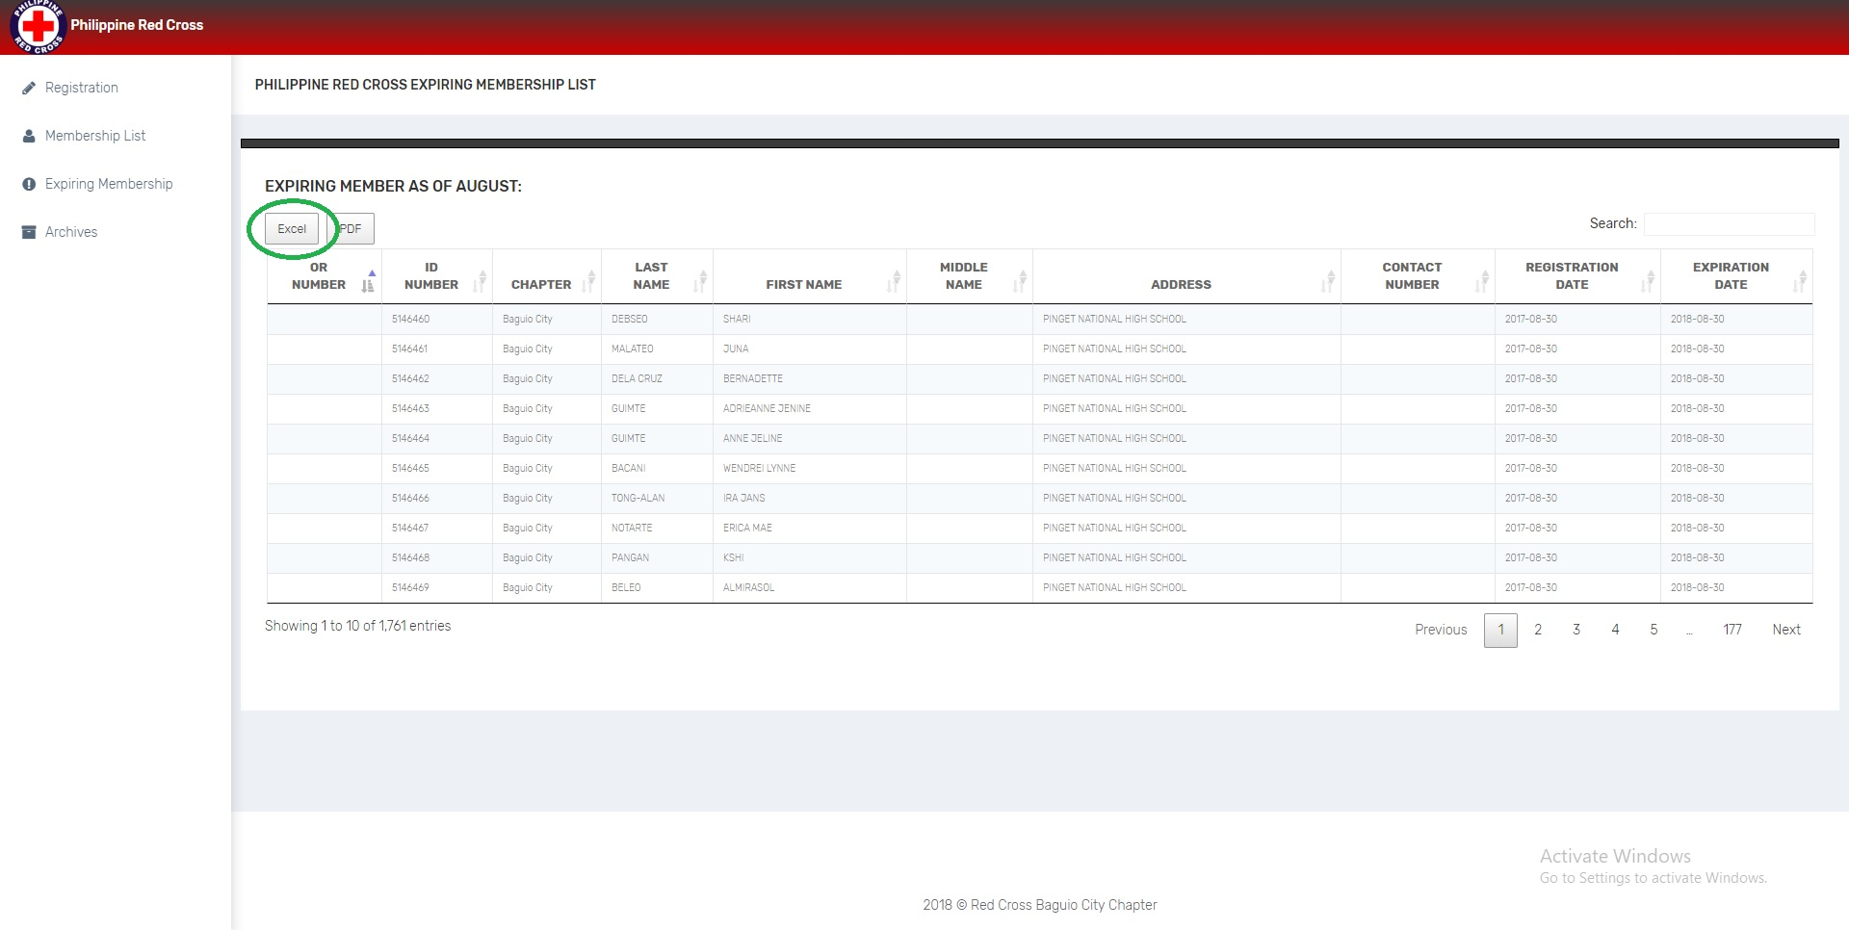

**Member List**

At the Membership page, there are different tab of type of membership such as *Classic, Bronze, Silver, Gold, Platinum, Senior and Senior Plus* including the *All* tab wherein all of the members are shown. If the user wants to have a copy of List of Membership in a specific type:

1. Click the tab of the desired type of membership.
2. Click “Excel” button and it will automatically download an excel file containing all of the information needed.

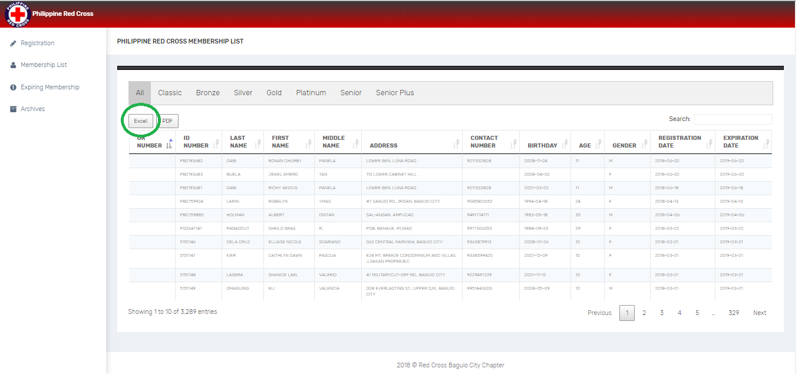

**By Specific Registration Date**

* If the user wants to have a copy of List of Membership in a specific registration date:

1. Put the desired date in the search box at the upper right of the table and follow the format of ***YEAR-MONTH-DATE.***
2. Click and choose “All” at the drop down at the upper left of the table.
3. Click “Save as Excel” button and it will automatically download an excel file.

**By Specific Month and Year**

* If the user wants to have a copy of List of Membership in a specific month and year:

1. Put the desired month and year in the search box at the upper right of the table and follow the format of ***YEAR-MONTH***.
2. Click and choose “All” at the drop down at the upper left of the table.
3. Click “Save as Excel” button and it will automatically download an excel file.

**By Specific Year**

* If the user wants to have a copy of List of Membership in a specific year:

1. Put the desired year in the search box at the upper right of the table.
2. Click and choose “All” at the drop down at the upper left of the table.
3. Click “Save as Excel” button and it will automatically download an excel file.